***Government College of Engineering, Bargur.***

***SMART PARKING USING IOT***

***Team members***

***Gowtham. B 61072111115***

***Aarthi. R 61072211901***

***Kaviya. S 61072211909***

***Ranjith kumar. M 61072211914***

***OBJECTIVE***

* The main aim of this project is reduces the risk of finding the parking slots in any parking area
* It eliminates the unnecessary travelling of vehicles across the filled parking slots in a city

**INTRODUCTION**

Internet of thing (IOT) has the ability to transfer data through network without involving human IoT allows user to use affordable wireless technology and also helps the user to transfer the data into the cloud . IOT helps the user to maintain transparency. The idea of IoT started with the Identity of things for connecting various devices. These devices can be controlled or monitored through computers over internet. IoT contains two prominent words “Internet” and “Things”, where Internet is a vast network for Connecting servers with devices [1]. Internet enables the Information to be sent, receive or even communicate with the devices. The parking problem causes air pollution and traffic congestion [4]. In today’s scenario, parking space is hard to search in a day to day life for the people. According To the recent survey, there will be a rapid increase in the vehicle’s population of over 1.6 billion around 2035 [7]. Around one million barrels of world’s oil is being burnt everyday [4]. Thus, smart parking system is the key solution to reduce the waste stage of the fuel. The solution for the problems that is being raised. The smart parking can be a solution to minimise user’s time and efficiency as well as the overall cost of the fuel burnt in search of the parking space. In this, the data is collected from the sensor and through analysing and processing, the output is obtained.[5]

**EXISTING SYSTEM**

In the Existing System they use parking camera for detecting the number of available cars in the parking area using threshold optimizing technique in image processing. The camera send the information to the fog node, fog nodes process the pictures from multiple camera in order to identify the number of available parking slots. Fog nodes connect to cloud through proxy server and user can access the information using internet .Fog nodes deployed at parking lots, cooperating with each other, enable real time parking slot information provisioning as well as parking requests processing. The cloud centre will enforce global optimization on parking requests allocation. The experimental results of our approaches show higher efficiency compared with other parking strategies. The fog computing-based smart parking can lower the average parking cost and minimize gasoline wastes and vehicle exhaust emission. One main disadvantage of the existing system is the user will not know the shortest path available to the parking slots. For example, if there are slots 2 and 5 free and cloud will not update the shortest path available to the user and this may lead to high fuel consumption in search of the parking slot.

**DISADVANTAGE**

The existing system will send the information from the cameras to fog nodes and it takes higher time for processing of these images. The user will not be aware of the shortest available parking slot in the parking space and also the user will not know are there any available parking slots in the parking space before entering. Resources such as fuel and time are wasted in search of the parking slot. The search for the parking slot will also leads to accidents because the users will be less focusing on road while searching

**PROPOSED SYSTEM**

We will make of micro-controller and this is used to process the instructions continuously in a loop. The user will first scan the RFID card using the RFID reader and the webpage will update the user details and even before the user scans the RFID card, the web page will display is there any available parking slot or not. After updating the user details on web page, a DC motor is used to open the gate for the user.Now the web page displays the available parking slots as well as the nearest parking slot to the user. IR sensors are used for the object detection in the paper and by object in this is the vehicle. As soon as the user parks the vehicle in the parking slot, the IR sensor will detect the object and forwards the information to the micro controller and the micro controller will process this information and update on the web page.

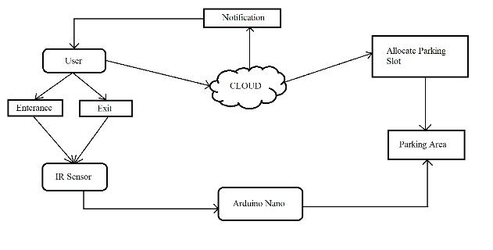**System Architecture**